**Smart Emergency Button**



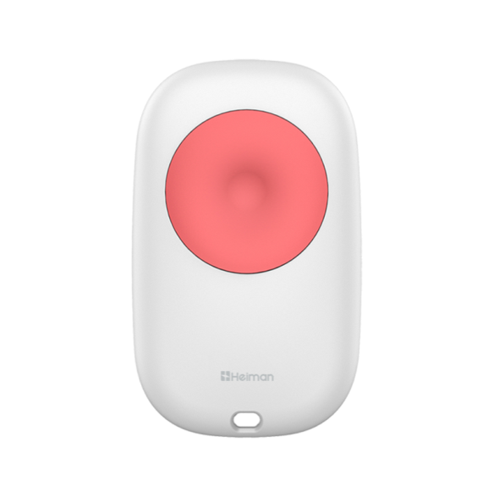

Specification

***Features***

* **ZigBee 3.0 protocol, good compatibility;**
* **One key alarm, for vulnerable group;**
* **Include hanger for wear on keyring;**
* **Low power consumption design;**
* **Can be portable use or hang on wall.**

***Premium Add-on device for your home***

This Emergency Button, adopts super low power consumption ZigBee wireless network technology, is a portable emergency push switch panic button for alarm.

* Model Number: HS1EB-TY
* Working Voltage: DC3V
* Battery Type: 1xCR2032 button cell
* Battery Life: 1 year
* Standby Current: <6uA
* Alarm Current: ≤30mA
* Install Height: surface mounted
* Networking Way: ZigBee 2.4GHz
* Anti-RF Interference: 80MHz — 1GHz 10V/m
* Working Temperature: -10℃ ～ +50℃
* Working Humidity: ≤95%RH
* Product Size: 57.5x34.5x13mm
* Gross Weight: 67g